**Cochrane Endurance Project XC Open 2024**

*Athletics Alberta XC Race Series #1*

1. Date – Saturday, Sept 14th, 2023
2. Venue – Mt. St. Francis Retreat Centre, 41160 Retreat Rd, Cochrane AB, T4C2W4
3. PARKING – Cochrane High School, BUS LOOP, 529 Fourth Ave N, Cochrane, AB T4C 1Y6
4. Schedule –
   1. U10 Girls – 11am – 1000m
   2. U10 Boys – 1115am – 1000m
   3. U12 Girls – 1130am – 1200m
   4. U12 Boys – 1200pm – 1200m
   5. U14 Girls – 1220pm – 2000m
   6. U14 Boys – 1240pm – 2000m
   7. HS Open (U16/U18) Mixed Relays (3x 2km loops) – 100pm
   8. HS/Open Women’s – 5km – 130pm
   9. HS/Open Men’s – 5km – 200pm
5. Course Map – Will be emailed to participants’ upon closing of registration one week prior to event – preliminary map(s) –

Long Loops – 2km

Intermediate Loops – 1.2km

Short Loops – 1km

Parking – WILL BE AT THE BUS LOOP AT COCHRANE HIGH (we have a shuttle taking people up to the meet site). DO NOT PARK AT MT. St Francis. Tent set-up and bathrooms indicated on maps.

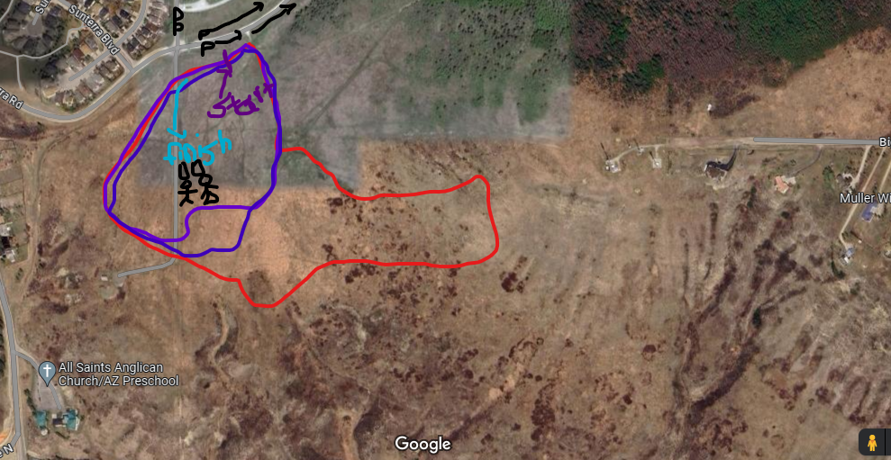

1. Entries –
   1. Due – 6pm WED SEPTEMBER 11th
   2. Please submit all entries using TrackieReg (<https://www.trackie.com/online-registration/>)
2. Entry Fee –
   1. To be paid to Trackie at time of registration
   2. $25.00
3. Contact – Meet Director – Travis Cummings – [traviscummings10km@gmail.com](mailto:traviscummings10km@gmail.com)
4. Results – FinishLynx system (no live results), results to be posted on the CTC and Athletics Alberta on Trackie within 24h of competition conclusion.
5. AWARDS – Swag/prizes to be given to winners of races courtesy of Strides Running Store/New Balance Canada if available at time of meet. Sorry all, no prize money this year!
6. Athletics Alberta Membership - All competitors must be members of Athletics Alberta. **No exceptions** -- please see https://www.athleticsalberta.com/aa-membership/ . (Note: "Day of Meet" memberships are **no longer available**. Membership must be registered before the meet entry)
7. COVID Protocols – emailed upon registration closing if required